Personal Brand Website

Definition:
# Source: AI Source: Provided by: [Data Path: Persons Table -> ID Column: 1, Name_En Column: Motasem Essam] -> From: [Chatgpt (GPT‑5 Mini)] on [2/12/2026]
A personal brand website is a type of personal website used to promote yourself as a brand, showcasing your skills, expertise, achievements, and personality to build a strong online presence.

Simple Definition
# Source: AI Source: Provided by: [Data Path: Persons Table -> ID Column: 1, Name_En Column: Motasem Essam] -> From: [Chatgpt (GPT‑5 Mini)] on [2/12/2026]
👉 Personal brand website = a website that represents you as a professional brand and highlights your expertise

Key Features
# Source: AI Source: Provided by: [Data Path: Persons Table -> ID Column: 1, Name_En Column: Motasem Essam] -> From: [Chatgpt (GPT‑5 Mini)] on [2/12/2026]
- About Me / Story – your background and journey
- Portfolio – your work and projects
- Blog / Articles – your ideas, knowledge, and opinions
- Services (optional) – what you offer (e.g., consulting, freelancing)
- Testimonials – feedback from clients or employers
- Contact information – email, social media, booking forms

Advantages
# Source: AI Source: Provided by: [Data Path: Persons Table -> ID Column: 1, Name_En Column: Motasem Essam] -> From: [Chatgpt (GPT‑5 Mini)] on [2/12/2026]
- ✅ Builds a strong personal identity online
- ✅ Helps attract clients, employers, or opportunities
- ✅ Combines portfolio, blog, and resume in one place
- ✅ Increases credibility and trust

Disadvantages
# Source: AI Source: Provided by: [Data Path: Persons Table -> ID Column: 1, Name_En Column: Motasem Essam] -> From: [Chatgpt (GPT‑5 Mini)] on [2/12/2026]
- ❌ Requires consistent updates and content creation
- ❌ Takes time to build a strong brand
- ❌ Needs effort to maintain a professional image
- ❌ May require hosting and domain costs

Use Cases
# Source: AI Source: Provided by: [Data Path: Persons Table -> ID Column: 1, Name_En Column: Motasem Essam] -> From: [Chatgpt (GPT‑5 Mini)] on [2/12/2026]
- Freelancers (designers, developers, writers)
- Consultants and coaches
- Influencers and public speakers
- Professionals building their career presence

Personal Brand Website vs Resume / CV Website

1. Personal Brand Website
# Source: AI Source: Provided by: [Data Path: Persons Table -> ID Column: 1, Name_En Column: Motasem Essam] -> From: [Chatgpt (GPT‑5 Mini)] on [2/12/2026]
👉 A personal brand website focuses on promoting you as a professional brand and building your identity online.
Main Focus
- Your image, expertise, and personality
Content Includes
- About Me / personal story
- Portfolio of work
- Blog or articles
- Services you offer
- Testimonials from clients
- Contact information
Purpose
- Build a strong online presence
- Attract clients, employers, or opportunities
- Showcase authority and credibility

2. Resume / CV Website
# Source: AI Source: Provided by: [Data Path: Persons Table -> ID Column: 1, Name_En Column: Motasem Essam] -> From: [Chatgpt (GPT‑5 Mini)] on [2/12/2026]
👉 A resume/CV website focuses on presenting your qualifications and work history in a structured way.
Main Focus
- Your skills, experience, and education
Content Includes
- Work experience
- Education
- Skills
- Certifications
- Downloadable CV
- Contact information
Purpose
- Help with job applications
- Provide a professional summary of your qualifications
- Act as an online version of your resume

Key Differences
# Source: AI Source: Provided by: [Data Path: Persons Table -> ID Column: 1, Name_En Column: Motasem Essam] -> From: [Chatgpt (GPT‑5 Mini)] on [2/12/2026]
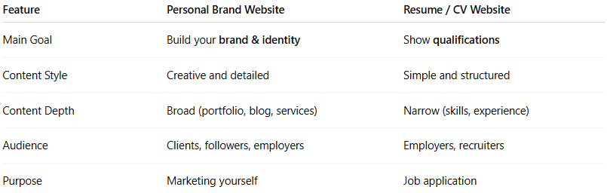
Feature | Personal Brand Website | Resume / CV Website
Main Goal | Build your brand & identity | Show qualifications
Content Style | Creative and detailed | Simple and structured
Content Depth | Broad (portfolio, blog, services) | Narrow (skills, experience)
Audience | Clients, followers, employers | Employers, recruiters
Purpose | Marketing yourself | Job application

Simple Analogy
# Source: AI Source: Provided by: [Data Path: Persons Table -> ID Column: 1, Name_En Column: Motasem Essam] -> From: [Chatgpt (GPT‑5 Mini)] on [2/12/2026]
- Personal Brand Website = Your public personality + professional identity
- Resume/CV Website = Your formal job application document online

Summary
👉 A resume/CV website is focused on your qualifications, while a personal brand website is focused on how you present yourself and grow your professional identity.

If you want, I can create a quick memory trick or exam summary to help you remember the difference easily.

Simple Example
# Source: AI Source: Provided by: [Data Path: Persons Table -> ID Column: 1, Name_En Column: Motasem Essam] -> From: [Chatgpt (GPT‑5 Mini)] on [2/12/2026]
A personal brand website might include:
- A homepage with your name and tagline
- A blog with articles
- A portfolio of your work
- A section describing your services
- A contact form for clients

Simple Analogy
# Source: AI Source: Provided by: [Data Path: Persons Table -> ID Column: 1, Name_En Column: Motasem Essam] -> From: [Chatgpt (GPT‑5 Mini)] on [2/12/2026]
Think of a personal brand website like a digital reputation or identity:
- It shows not just what you do, but who you are as a professional
- It builds how people perceive and trust you online

Summary
# Source: AI Source: Provided by: [Data Path: Persons Table -> ID Column: 1, Name_En Column: Motasem Essam] -> From: [Chatgpt (GPT‑5 Mini)] on [2/12/2026]
👉 Personal brand website = a personal website that promotes your identity, expertise, and professional image as a brand

